12.85: a) 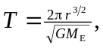 therefore
Since 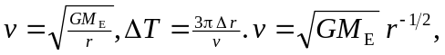 therefore Since 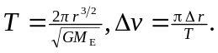
b) Note: Because of the small change in r, several significant figures are needed to see the results. Starting with 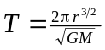 (Eq.(12.14)), 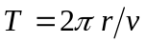, and 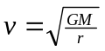 (Eq.(12.12)) find the velocity and period of the initial orbit: 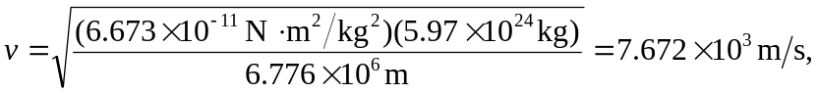and 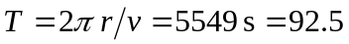 min. We then can use the two derived equations to approximate the
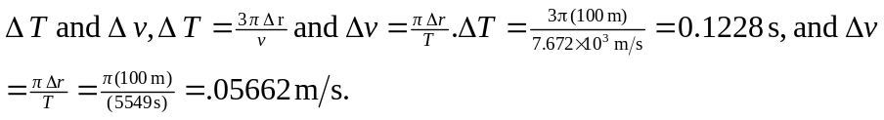
Before the cable breaks, the shuttle will have traveled a distance d, d min. It will take 22 minutes for the cable to break.
c) The ISS is moving faster than the space shuttle, so the total angle it covers in an orbit must be 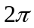radians more than the angle that the space shuttle covers before they are once again in line. Mathematically,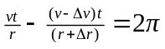. Using the binomial theorem and neglecting terms of order 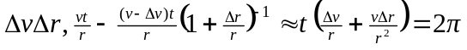. Therefore, 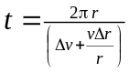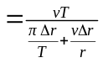. Since 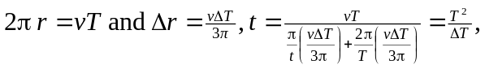 as was to be shown. 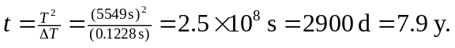 It is highly doubtful the shuttle crew would survive the congressional hearings if they miss!

